ODTML Interface Control Document
USNA Small Satellite Program
MIDN 1/c Aaron Okun

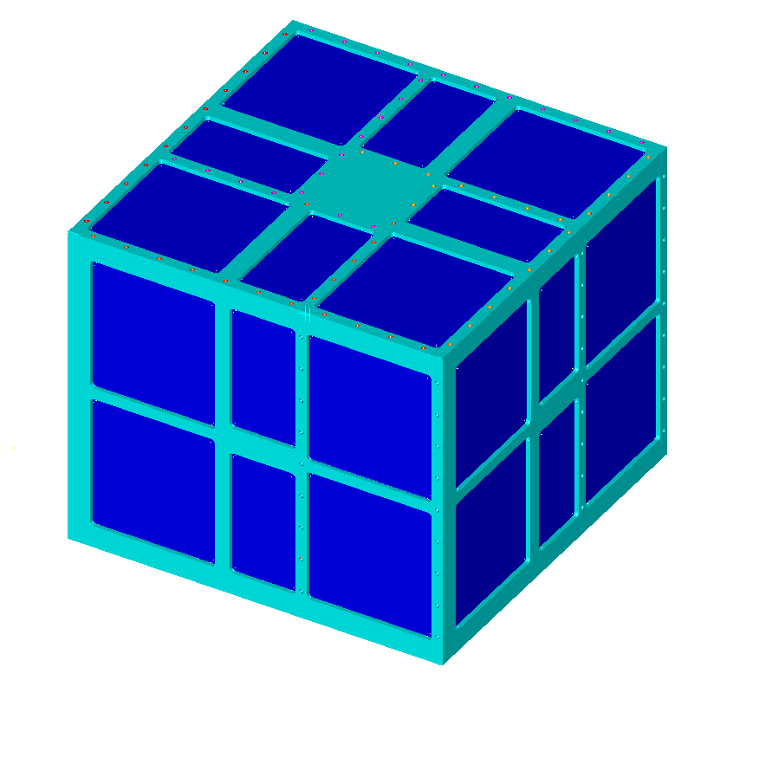

United States Naval Academy
Annapolis, Maryland

SIGNATURES

Reviewed by:
 | Name, Title, email |  | Date
Reviewed by:
 | Name, Title, email |  | Date
Reviewed by:
 | Name, Title, email |  | Date
Reviewed by:
 | Name, Title, email |  | Date

Revision Log

Revision | Description | Author | Date | Approval
1
2
3
4
5
6
7
8
9
10

Table of contents

Revision Log 2
Table of contents 3
List of Drawings 4
Acronyms 4
1 Introduction 5
1.1 Scope 5
1.2 ParkinsonSAT Description 5
1.3 ODTML Experimental Description 6
2 Administration 7
2.1 Configuration Management 7
2.2 Precedence of Documents 7
3 Interface Definitions and Description 8
3.1 Units 8
3.2 ODTML 8
3.2.1 Mechanical Interfaces 8
3.2.2 Mounting and Alignment 9
3.2.3 Thermal Interfaces 9
3.2.4 Electrical Connections 10
3.3 Electrical Power: 11
3.3.1 Voltage 11
3.3.2 Current 11
3.3.3 Power Quality 11
3.3.4 Loads 11
3.3.5 Grounding 11
3.3.6 Power Draw Profiles 12
3.4 Discrete Electrical Signals 12
3.4.1 Discrete Analog Inputs 12
3.4.2 Discrete Analog Outputs 12
3.4.3 Discrete Digital Inputs 13
3.4.4 Discrete Digital Outputs 13
Possibly 1 or two discrete on/off bits 13
3.5 Serial Digital Communications 13
3.5.1 Input Signals from ParkinsonSAT to ODTML 13
3.5.2 Output Signals from ODTML to ParkinsonSAT 14
3.6 Software Interfaces 14
3.6.1 Serial Data Bus 14
3.6.2 Flow Control 15
3.6.3 Hardware Handshaking: 15

List of Drawings
Figure 1: ParkinsonSAT 5
Figure 2: The Global Internet Linked ParkinsonSAT Ground Station Network 5
Figure 3: ODTML Mission 6
Figure 3: ODTML Compartment Size 8

Acronyms
$\text{ADCS}$ attitude and directional control system
$\text{CPU}$ computer processing unit
$\text{EPS}$ electric power system
$\text{HDLC}$ High-Level Data Link Control
$\text{ISS}$ International Space Station
$\text{NASA}$ National Aeronautics and Space Administration
$\text{NRL}$ Naval Research Laboratory
ODTML Ocean Data Telemetry Microsat
$\text{PSAT}$ Parkinsonsat
SSP Small Satellite Program
$\text{USNA}$ United States Naval Academy

Introduction

Scope
This document shall cover specifications and areas of responsibility for all issues relevant to the interface between ODTML under design by NRL and the PSAT under design by the USNA SSP.

ParkinsonSAT Description
The primary mission of PSAT is to be a satellite communications transponder for data exfoliation. To accomplish this primary mission, it will contain an Ocean Data Telemetry Microsat Link (ODTML) transponder for DOD related ocean buoys and data sources and an AMSAT transponder operating in the Amateur Satellite Service for educational and academic use by students and universities.
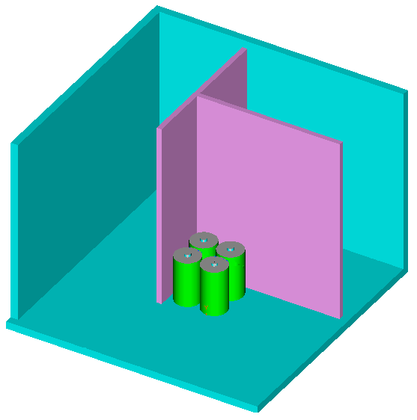
Figure 1: ParkinsonSAT
A key element in this mission design is the use of a global network of volunteer ground stations to collect and feed the downlink data into the internet for live distribution to all experimenters as shown in Figure 2.
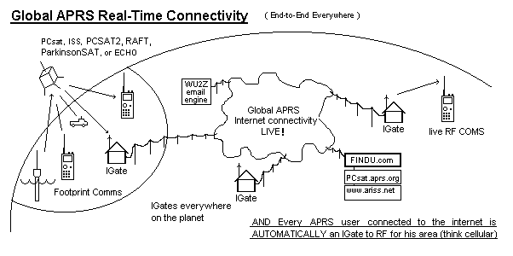
Figure 2: The Global Internet Linked ParkinsonSAT Ground Station Network

Under this concept, the US Naval Academy is the primary command and control ground station for commanding, but downlink information is provided on as near a real-time basis as possible depending on the availability of other ground stations around the world.

The secondary missions of PSAT will be, among others, to support the following additional payloads and missions:

MiDN – A joint ONR/ Naval Academy Micro Dosemeter for radiation measurements
UHF-RFI – A joint NRL/Naval Academy UHF Interference Mitigation Receiver
SPID – A joint ONR/USNA Small Particle Impact Detector.

ODTML Experimental Description
The following interface design specifications are provided for the interface between ParkinsonSAT and ODTML to include size, voltage, mass, temperature requirements, and communications protocol. ODTML, Ocean Data Telemetry Link, will have a multiple UHF frequencies and an FPGA controller. It will monitor ocean buoys using with radio frequencies as it orbits within PSAT. The buoys will transmit telemetry (temperature, salinity, etc.) to ODTML. This telemetry will be sent to ground stations via PSAT.

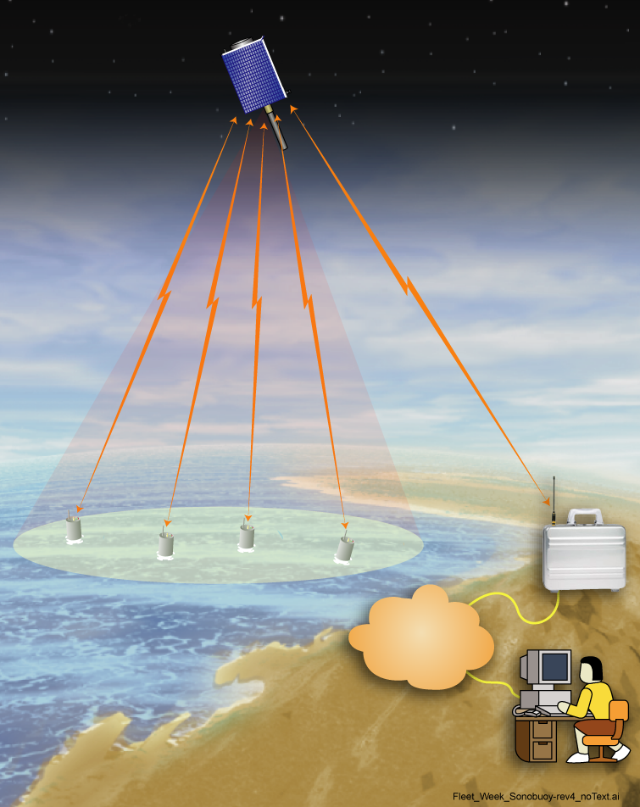

GROUND
STATION

Ocean Buoys
INTERNET

Figure 3: ODTML Mission

Administration

Configuration Management
This document shall be updated at the mutual agreement of the NRL and the SSP Principal Investigator, CDR Bruninga, USN, (ret). Changes may be suggested, negotiated and assented to by email. The latest mutually agreed upon electronic version of this document shall have the same force and standing as a signed paper document.

Precedence of Documents
This document has precedence over any and all other written, verbal or electronic statements addressing interface issues.

Interface Definitions and Description

Units
Both English and metric units shall be used in all cases where both are defined.

ODTML

Mechanical Interfaces

Physical Properties

Dimensions
ODTML will be placed in a compartment with dimensions of 7.375 in X 4.25 in X 10.5 in. as shown in figure 3. In addition, an external location will be provided for an external monopole UHF antenna, on the order of 10” in length.
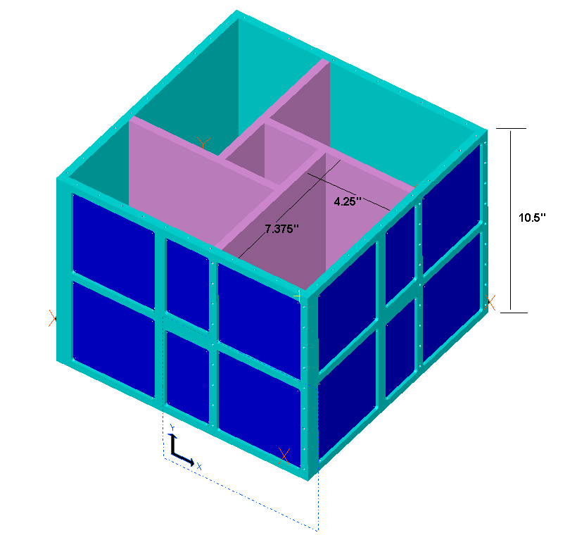
Figure 4: ODTML Compartment Size

Materials
All materials must be space rated. Aluminum shall be 6061 except were noted.

Mass
The mass of ODTML will be no more than 3.7 kg.

Surface Treatments
The surfaces of ODTML must be anodized or iridated. All exterior ODTML surfaces must anodized black for best radiative heat transfer within the spacecraft.

Mounting and Alignment

Mounting Specifications
ODTML will be located in a 7.375 in X 4.25 in X 10.5 in. sidewall compartment within PSAT. This compartment will be designed so that two of the sides are the external surfaces of the satellite while the other two sides are the internal thermal bulkhead. Preferably, a majority of the mass of ODTML should be mounted towards the external portion of the spacecraft for best attitude dynamics. Mounting hardware will consist of #6-32 or #4-40 screws.

Alignment Specifications
Although there are no specific alignment specifications, it should be noted that the sun facing attitude of the –Z PSAT face will result in a significant temperature gradient from the –Z to the +Z faces.

Thermal Interfaces

Temperature Limits
Space frame mounting surfaces will range from -10 to +40 degrees Celsius operational and -40 and +60 degrees C storage and extremes. During stable attitude control the average spacecraft temperature should range between 0 deg C and 30 deg C depending on orbit inclination, precession and eclipse periods.

Temperature Monitoring Components
At least one thermistor, type number Digi-Key KC006-ND will be required on what will be the warmest component of ODTML for reporting nominal spacecraft health in the PSAT telemetry system.

Thermal Control Components
The assigned volume for ODTML has an internal and external spacecraft surface. The external surfaces may see temperature fluctuations of + or – 15 degrees C per orbit depending on attitude. The internal surface may see temperature fluctuations of + or – 5 degrees C or less per orbit. The average overall temperature of the spacecraft will vary between 0 and +30 degrees C over all sun beta angles. The thermal control components will be left to the choice of ODMTL, but the PSAT power budget cannot support heaters of any kind. Passive thermal control techniques are required.

Electrical Connections

Connector Hardware Specifications
Connectors will consist of crimp pin “DB type ” connectors for the flight model. There will be associated pins corresponding with; the double redundant positive terminals of the battery, telemetry for the resistive grid as well as telemetry for the acoustic PINDROP sensors. At no time shall the current in any pin exceed 600 mA average and 2.5 amps peak.

Ground Straps
Since all ODTML components except the antenna are internal, there are no ground strap requirements other than the single point ground return pins in all connectors.

Connector Pin-outs
+8 V Bus-A – Power from the A system
+8 V Bus-B – Power from the B system
ODTML TXD - Serial Port from ODTML to Psat
ODTML RXD – Serial Port from Psat to ODTML
ODTML GND – Signal Ground
Status bit1 – digital discrete TBD
Status bit 2 – digital discrete TBD
Thermister+
Thermister-
8 V Return A
8 V Return B

Bonding Specifications
All space frame components are conducting and are considered a common safety ground.

Intra-payload Harness
ODTML will be an independent payload, thus there will be no opportunities to cross link with other payloads aboard the flight unit.

Electrical Power:
The electrical power is provided from the Psat power system to various payloads via two nearly identical bus systems called the A and B buses. The power to these buses is controlled by the A and B side controllers to provide dual redundant payload power control. Normally only one side will be activated and can provide the specified payload power. Both sides however, can be activated at the same time, but the power limits remain the same. In otherwords, the power available to the (ODTML) remains the same whether one or both busses are connected.

Voltage
Both bus A and B will be unregulated 8 volts. This will be distributed using a #20 AWG wire.

Current
Both sides bus A and B can provide a total of 625 mA average current to ODTML. The peak instantaneous current can be up to 5 amps. The fuse will be rated at 10 amps.

Power Quality
The unregulated 8 volt bus is driven by six NiCd cells and will vary between 7.2 and 8.4 volts operationally. A low voltage cut out will occur at 6 volts. During battery charging, bus voltages as high as 8.8 volts can occur.

Loads
The peak load from ODTML can not exceed 5 amps for more than 5 seconds. The duty cycle of such peak loads cannot exceed 12.5 percent or a maximum total average power of 5 watts.

Grounding
Both buses will be grounded to a single ground point.

Power Draw Profiles

Average Power
The whole orbit average power over a twenty four hour basis shall not exceed 5 watts on the 8 volt bus. The power to ODTML is under the control of the PSAT operating system and will be enabled as a primary mission objective as long as there is adequate power available.

Peak Power
The peak power available to ODTML is 40 watts.

Nominal Operating Power
Nominal Average Operating power is 5 watts at 8 volts.

Standby Power
Stand by power is .16 watts at 8 volts. Stand by power may be lost during periods of low spacecraft power or under-voltage conditions.

Duty Cycles
As noted above, peak power and duty cycle will not exceed the average power noted in paragraph 3.3.6.1.

Discrete Electrical Signals

Discrete Analog Inputs
The thermister is digi-key part # KC006-ND. The calibration date is provided in appendix _________.

Thermister +.

Thermister return

Discrete Analog Outputs
TBD

Discrete Digital Inputs
Possibly 1 or 2 discrete I/O status lines

Discrete Digital Outputs

Possibly 1 or two discrete on/off bits

Serial Digital Communications
ODTML RXD - RS-232 received data from ParkinsonSAT to ODTML.
ODTML TXD - RS-232 transmit data from ODTML to ParkinsonSAT.
ODTML RTS - Request-to-send line from ODTML to Psat
ODTML CTS - Clear-to-send line from Psat to ODTML
ODTML GND – signal ground

Input Signals from ParkinsonSAT to ODTML

Signals Characteristics
The primary communications path between Psat and ODTML is via the serial port to provide remote terminal (RT) message store and forward operations and serial communications to interface to the ODTML transceiver radio. Signals will use either RS-232, RS-422 on TLL levels 0-5 volts.

Command Protocols
All commands from ParkinsonSAT to ODTML will use the printable ASCII subset with no control codes. The presence of extraneous ASCII character in the serial data bus to other payloads will occur. ODTML protocols must be immune to the other unintended signals on the serial port bus.

Data Input Protocols
The receive data will have a serial interface

Command Upload Protocols

Output Signals from ODTML to ParkinsonSAT

Signal Characteristics
Same as 3.5.2.2 Command Protocols

Telemetry Output Protocols
There will be several telemetry outputs from ODTML. A plus and minus temperature will be required using an AWG #24 wire. One status bit will be place on PSAT. There will be a ground.

Data Output Protocols
The transmit data will occur at 9600 Baud. The experiment serial data bus will contain packetized printable ASCII data to and from all onboard experiments, to and from all user ground stations and any other serial data on the channel. The ODTML processor must ignore all such data except for the packets specifically addressed to it. There is no software flow control.

SPID may transmit onto the bus only if CTS is clean and when it begins to transmit, it must

Software Interfaces

Serial Data Bus

The ParkinsonSAT payload serial data bus will contain packetized printable ASCII data to and from all onboard experiments, and also to and from all user ground stations and any other serial data on the channel. The individual payload processors (ODTML) must ignore all such data except for the packets specifically addressed to it. All data on the Serial Data Bus will be in the following standard AX.25 format:
SOURCE>DEST,PATH,PATH:xxxxxxxxxxxxxxxxxx….

Where SOURCE is a 3 to 9 byte variable length field indicating the originator of the packet. Only the uppercase and numeric characters are used in the first 6 bytes and the final 3 may contain a one or two byte numeric field (“-1” to “-15”).

Where DEST is a 3 to 6 byte destination field. This field has the same character restrictions as the source. Since most data on the payload bus is transmitted in broadcast manner, the destination field is often used to indicate a version number or other identifier.

Where PATH is a series of from none to seven comma separated fields indicating the RF path for the data. These fields are also limited to the character restrictions of the source field. Typically if a packet is relayed by a ground station or another satellite, the callsign of that station will be included here.

Where all data after the “:” colon is free field from 0 to 128 bytes.

Flow Control

There is no software flow control.

Hardware Handshaking:

ODTML may transmit onto the bus only if CTS is clear and when it begins to transmit, it must assert RTS.

